Example Process – CLOVER project

All of our equipment is kept under strict guidelines to maintain calibration

This is the folder where we keep all of our calibration certificates for all of the equipment we use (that require calibration):

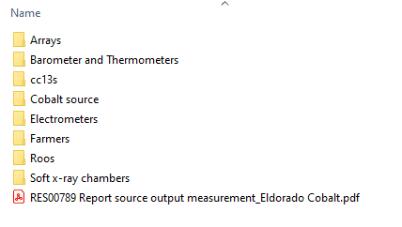

If we go into the Farmers folder:

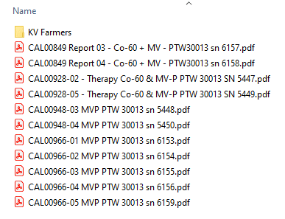

I will send you some example certificates.

For now, I’ll go through an example of what we do when we get a calibration certificate. Let’s say we just received CAL00948-03 MVP PTW 30013 sn 5448.pdf

1. Open up the ARPANSA-FORM-9042-v6 All Levels Calibration Data – working.XLSX
2. Open up the calibration certificate and check the number and date of the calibration:

Update the Report Date and Cal # in the spreadsheet

We tend to work from the left of the spreadsheet to the right, and fill in the data required

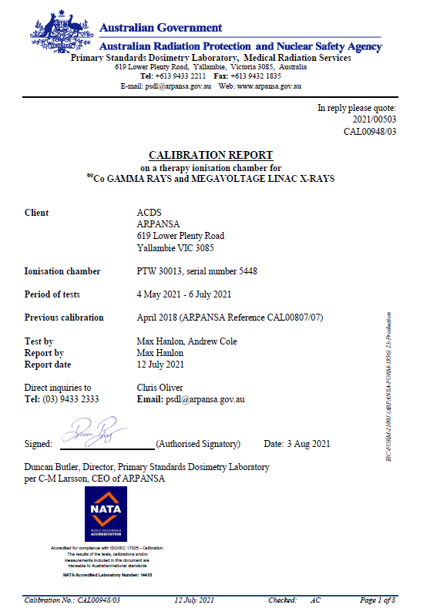

1. Go to Page 3 where there is this table:

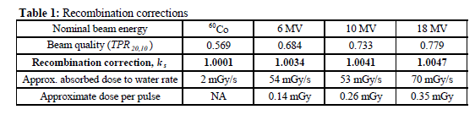

1. Update the spreadsheet with the new Recombination correction ks factors

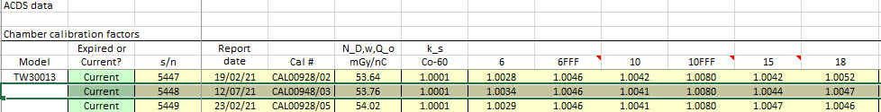

1. Update the spreadsheet with the values of kpol from Table 2
2. Go to page 6 and find the ND,w value and update the spreadsheet:

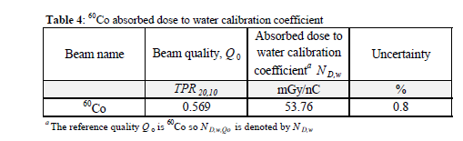

1. Go to page 7 of the report and update the kQ values for a, b, and c in the spreadsheet

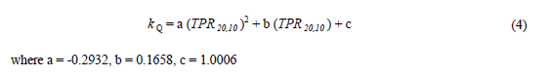

1. Save the spreadsheet and the new calibration certificate in the appropriate locations.
2. We then get a second person to review the data entry and check that it is all okay.

So for the CLOVER app, we will need to incorporate this process – one person inputs the new data and updates the calibration, then a second person needs to check the data before it goes “live”.

That’s it really. We just hunt through the calibration certificate for the values that we need and then manually input them into the master spreadsheet. We get someone to check them before updating everything and making it “live”.

This above example is for a Farmer chamber, but as you can see in the rest of the spreadsheet, other equipment doesn’t need as much data, or is slightly different for the master spreadsheet. Depending on what piece of equipment we are using, different correction factors are required for the audit calculations.